Lake Erie Walleye with Edamame
This recipe and photography was provided courtesy of local cookbook author and chef, Carla Snyder. Learn more about Carla and discover her recipes at Ravenouskitchen.com, or in her cookbook, One Pan Whole Family.
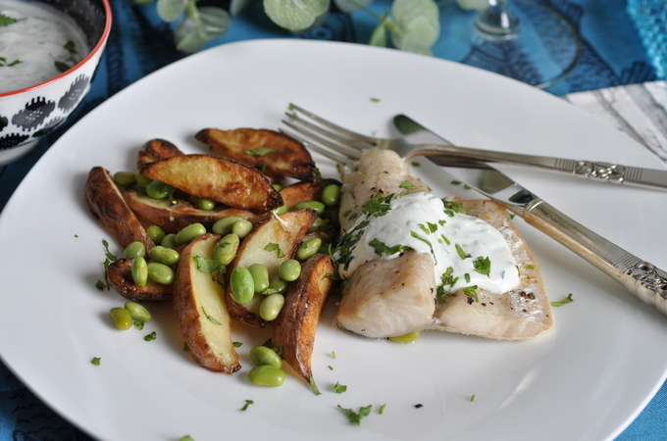
Ingredients:
- 1-lb new potatoes
- 2 cloves garlic
- 2 tablespoons olive oil, divided
- 1/2 teaspoon salt, plus more for sprinkling
- Freshly ground black pepper
- 1 cup Greek 2% fat yogurt
- 2 tablespoons chopped cilantro
- 1/2 teaspoons lemon zest
- 4 teaspoons lemon juice
- Pinch of cayenne
- Four 6 to 8-oz walleye fillets
- 1 cup frozen, shelled edamame, no need to thaw
Instructions:
- Preheat oven to 425ºF (To save time, place a foil lined sheet pan in the oven to preheat).
- On a large cutting board, slice the potatoes in half and then each half into 4 wedges, chop the garlic and add it all to a medium bowl. Stir in 1 tablespoon oil, 1/2 teaspoon salt and a few grinds of pepper.
- Remove the hot sheet pan from the oven, dump the potatoes on it and spread them out so that they cook evenly. Roast the potatoes for about 20 minutes or until browned on the bottom.
- While the potatoes roast, combine the yogurt, cilantro, zest, 2 teaspoons lemon juice, cayenne and a sprinkle of salt in a small bowl and keep refrigerated.
- Combine the remaining 2 teaspoons juice and 1 tablespoon oil in a small bowl with a sprinkle of salt and pepper.
- Pat the fish dry with paper towels and salt and pepper them. Remove the potatoes from the oven and flip them over with a thin edged spatula. Move potatoes to one side of the pan and sprinkle over the edamame. Lay the fish onto the cleared space and drizzle with the lemon/oil mixture. Return the pan to the oven for 10 minutes or until the fish is cooked through and flakes easily with a fork and the potatoes are browned and tender. (It’s easy to remove the skin: slide the edge of the spatula between the skin and flesh and separate the flesh from the skin. The filets might break up a bit but the skin should stick to the foil.)
- Serve the fish and potatoes on heated plates with a dollop of lemon yogurt on top.

